Create LocationIDs.csv for CCH Import Helper

Run the Export “CCH - Location lookup table” and download the output as “LocationIDs.csv”

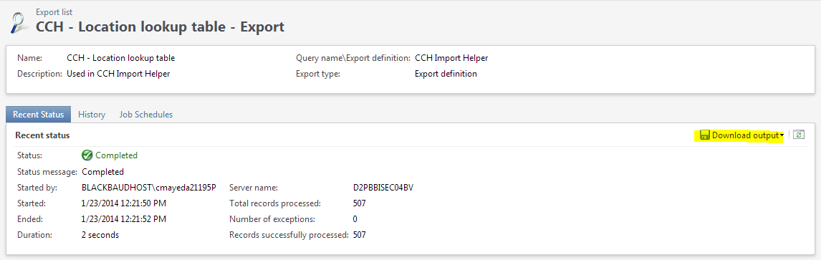

Open LocationIDs.csv in Excel.

Delete Column A (BUSINESSPROCESSOUTPUT_PKID)

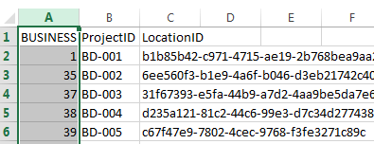

Save As csv to the same file name. This removes the quote delimiters that CRM puts in the export. Close Excel without saving again.

This file is placed in the folder specific in the App.config file (ChildCaseStudyImportHelper.exe.config) for the CCH Import Helper. The default location is C:\OCM\Locations.

Create All Projects.csv for CCH PlugIn Host

Run the Export “All - Active Projects” and download the output as “All Projects.csv”

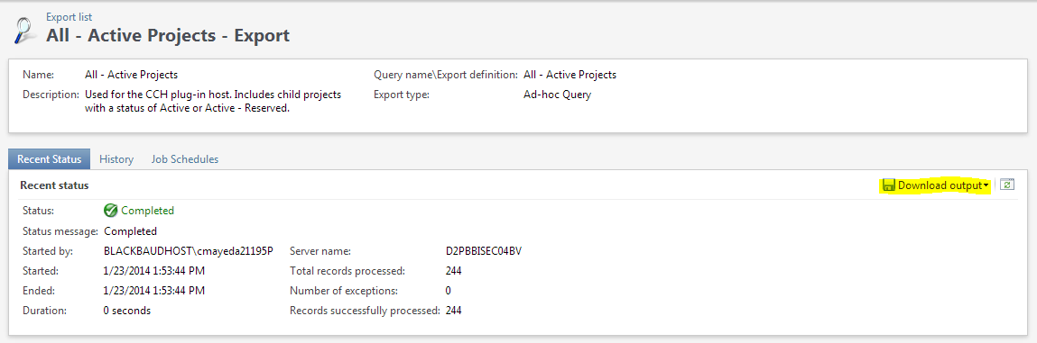

Open “All Projects.csv” in Excel.

Delete Column A (BUSINESSPROCESSOUTPUT_PKID)

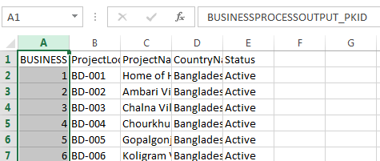

Save As csv to the same file name. This removes the quote delimiters that CRM puts in the export. Close Excel without saving again.

This file is placed in the folder specific in the App.config file (PlugInHost.exe.config) for the PlugInHost. The default location in HQ (COS) is \\HANNAH\mom\_Raiser's Edge\Plug-in Host\MoM. The default location for the field is c:\MoM. This file is also emailed to ICM (Andrew and Michelle) to be distributed to the field.